Perineal suturing competency- ongoing record of practice
Name: ________________________________________ HE#:
Date: | UMRN:
Assessment of level of trauma  ☐1st degree tear  ☐2nd degree tear  ☐Episiotomy – type  ☐Other  Draw level of trauma  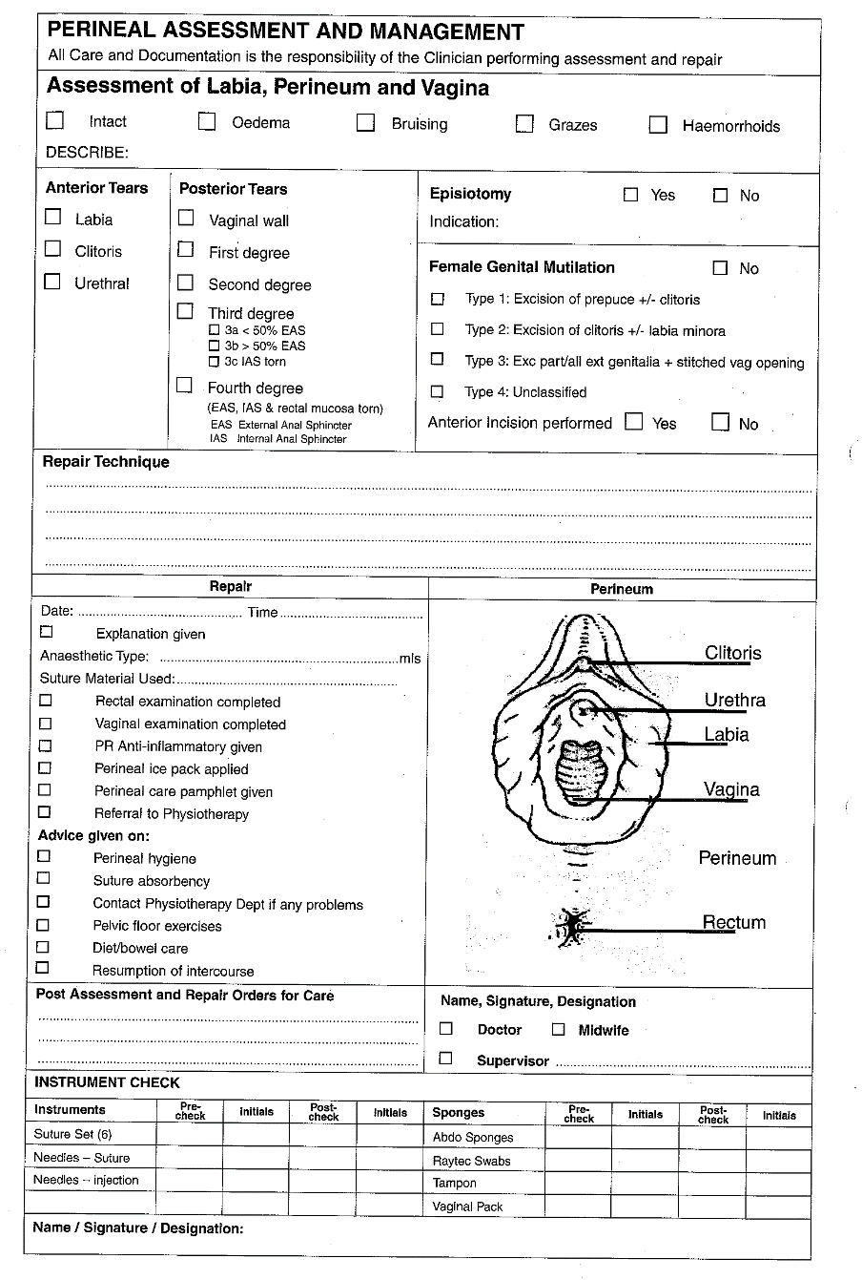 | Details of repair undertaken  Supervisor name:
Date: | UMRN:
Assessment of level of trauma  ☐1st degree tear  ☐2nd degree tear  ☐Episiotomy – type  ☐Other  Draw level of trauma | Details of repair undertaken  Supervisor name:

Date: | UMRN:
Assessment of level of trauma  ☐1st degree tear  ☐2nd degree tear  ☐Episiotomy – type  ☐Other  Draw level of trauma | Details of repair undertaken  Supervisor name:
Date: | UMRN:
Assessment of level of trauma  ☐1st degree tear  ☐2nd degree tear  ☐Episiotomy – type  ☐Other  Draw level of trauma | Details of repair undertaken  Supervisor name:
Date: | UMRN:
Assessment of level of trauma  ☐1st degree tear  ☐2nd degree tear  ☐Episiotomy – type  ☐Other  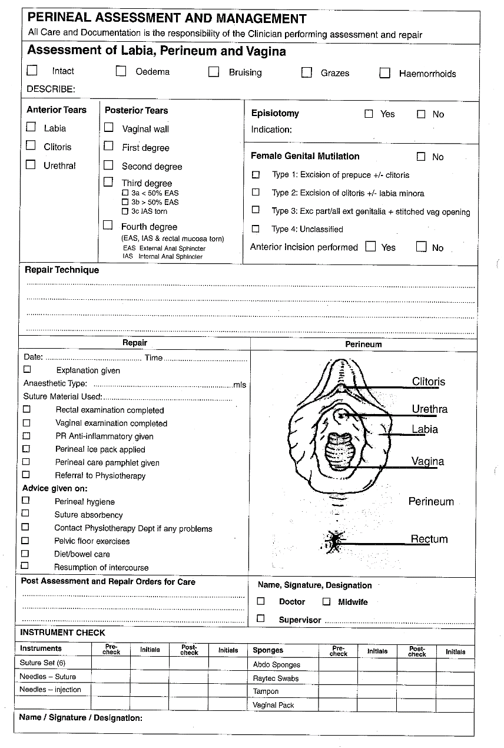  Draw level of trauma | Details of repair undertaken  Supervisor name:

