WNHS Professional Development Review (PDR) – Midwife, Registered Nurse, Enrolled Nurse

NMHS PDR guideline and flowchart

**The NMHS nursing and midwifery professional development review guideline and flowchart is available from:** [Performance Development and Review (health.wa.gov.au)](https://nmhs-healthpoint.hdwa.health.wa.gov.au/workingatnmhs/PDR/Pages/default.aspx)

|  |  |
| --- | --- |
| **Details** | |
| **Name:** |  |
| **Employee Number:** |  |
| **Position:** |  |
| **Directorate/Department:** |  |
| **Manager:** |  |
| **Date:** |  |

|  |  |  |
| --- | --- | --- |
| **Optional meeting declaration** | | |
| **Midwife/Nurse requests meeting (Optional)** | Yes 🞏 No 🞏 | **Signature:** |
| **Manager/Supervisor requests meeting (Optional)** | Yes 🞏 No 🞏 | **Signature:** |
| **Midwife/Nurse declines meeting (Optional)** | Yes 🞏 No 🞏 | **Signature:** |
| **Midwife/Nurse accepts meeting (Optional)** | Yes 🞏 No 🞏 | **Signature:** |
| **Entered into recording system** | Yes 🞏 No 🞏 | |

# Nursing & Midwifery Board of Australia (NMBA) requirements

You are reminded that annual renewal of registration for all midwives and nurses is required by 31 May each year.

The information included in your WNHS PDR for midwives and nurses should assist you to respond to an audit request by the NMBA should this occur.

The NMBA may choose to audit one or more of the following four mandatory registration standards:

* Criminal history registration
* Continuing professional development (20 hours CPD each for midwifery & nursing)
* Recency of practice (450 hours in 5 years for each profession you are registered in)
* Professional indemnity insurance arrangements (*should you require evidence of this you are advised to contact the Executive Secretary to the Director of Midwifery, Nursing & Patient Support Services for a standard letter that is available from the hospital confirming this arrangement*)

Further information can be accessed at:

<http://www.nursingmidwiferyboard.gov.au/Registration-and-Endorsement/Audit.aspx>

You are encouraged to retain a copy of this document for your personal records.

# Part 1: Mandatory education & training checklist

Staff development will review your mandatory training checklist on an annual basis. Staff are encouraged to bring this PDR document and their mandatory training checklist to compulsory in-service (CI). They are collected at CI and sent to staff development.

Please include a copy of your completed mandatory training checklist when submitting your PDR for review. The mandatory training checklist is available from: [King Edward Memorial Hospital - Professional Development Review (PDR) (health.wa.gov.au)](https://www.kemh.health.wa.gov.au/For-Health-Professionals/Education-hub/DNAMER/PDR)

It is recommended that this PDR and your mandatory training checklist in completed digitally.

# Annual clinical competency checklist

|  |  |
| --- | --- |
| 🞏 Applicable 🞏 Not applicable | |
| **I confirm that I continue to perform the following skills and have maintained my competency.** | |
| **Name:** | |
| **Signature:** | **Date:** |

|  |  |
| --- | --- |
| **Competency** | **✓ if applicable** |
| Adult PIVC insertion |  |
| Adult venepuncture |  |
| Basic ultrasound scanning (midwives) |  |
| Epidural analgesia administration |  |
| Full physical examination of the Newborn |  |
| IV opioid administration (EC) |  |
| Methotrexate administration |  |
| Neonatal IV medication administration |  |
| Perineal suturing |  |
| Rectus sheath analgesia administration |  |
| Sterile water for injection |  |
| Transcervical foley insertion: IOL |  |
| Trophon™ competency |  |
| Water immersion for labour and birth |  |

**Comments:**

# BFHI Group 1 core skills and knowledge – Annual review

|  |  |
| --- | --- |
| **🞏 Applicable 🞏 Not Applicable** | |
| **I confirm that I have achieved the breastfeeding core skills and knowledge by direct or in-direct supervision.** | |
| **Name:** | |
| **Signature:** | **Date:** |

|  |  |  |
| --- | --- | --- |
| **Core skills and knowledge requirements** | | |
|  | **Achieved ✓** | **Add to education plan ✓** |
| **Counselling skills** | | |
| 1. Use listening skills when counselling a mother |  |  |
| 1. Use skills for building a mother’s confidence and giving support |  |  |
| 1. Counsel a pregnant woman about breastfeeding |  |  |
| 1. Counsel a mother to make an informed and appropriate decision about infant feeding, suitable to her circumstances |  |  |
| **Establishing breastfeeding** | | |
| 1. Help a mother to recognise when her baby is ready to initiate breastfeeding while in skin-to-skin contact after birth |  |  |
| 1. Support a mother to position herself and her baby for breastfeeding |  |  |
| 1. Support a mother to attach her baby to the breast, encouraging baby-led attachment |  |  |
| 1. Assess a breastfeed; including teaching a mother how to monitor milk transfer |  |  |
| 1. Explain to a mother about feeding cues and the optimal pattern of breastfeeding |  |  |
| 1. Using hands-off techniques, assist a mother to express her breast milk |  |  |
| 1. Explain to a mother how to know if her baby is getting enough milk |  |  |
| **Breastfeeding challenges** | | |
| 1. Counsel a mother who thinks she does not have enough milk |  |  |
| 1. Counsel a mother with an unsettled baby |  |  |
| 1. Counsel a mother on selecting and using an alternative feeding method |  |  |
| 1. Counsel a mother whose baby is refusing to breastfeed |  |  |
| 1. Counsel a mother who has flat or inverted nipples |  |  |
| 1. Counsel a mother with engorged breasts |  |  |
| 1. Counsel a mother with sore or cracked nipples |  |  |
| 1. Counsel a mother with mastitis |  |  |
| 1. Support a mother to breastfeed a low-birth-weight, preterm or sick baby |  |  |

### Breastfeeding education plan for next 3 years:

|  |  |
| --- | --- |
| **Topic** | **Action** |
| *Counsel a mother with mastitis* | *Read clinical guideline, complete BF challenges module* |
|  |  |

# Section 2:PDR meeting (optional)

# Optional Midwifery/Nursing CPD record for previous 12 months

*(Continuing Professional Development activities you have attended/completed such as study days, in-service, reading an article)*

|  |  |  |  |  |  |
| --- | --- | --- | --- | --- | --- |
| **No** | **Date**  **attended** | **Activity** | **Reflection on activity** | **CPD Hours** | |
| **Nursing** | **Midwifery** |
| ***1*** | *Example*  *21/11/16* | *InTime – simulation study day (KEMH)* | *Opportunity to practice my skills in a safe environment. Take home message was to provide feedback once tasks had been completed – I aim to include this in my clinical practice* |  | *7* |
|  |  |  |  |  |  |
|  |  |  |  |  |  |
|  |  |  |  |  |  |
|  |  |  |  |  |  |
|  |  |  |  |  |  |
|  |  |  |  |  |  |
|  |  |  |  |  |  |
|  |  |  |  |  |  |
|  |  |  |  |  |  |
|  |  |  |  |  |  |
| **TOTAL HOURS** | | | |  |  |

*Staff who use alternative recordkeeping methods may present these documents (ANF, ACM, excel spreadsheet, Ausmed) at time of review as evidence of completion, rather than type information into this table*

# Optional Learning and development plan

Identify any learning or development needs to enable optimal performance and plan how these will be addressed. Consider also any development needed to help prepare for future career aspirations.

It is recommended that a 70:20:10 approach is adopted. This model supports the view that learning and development is most effective when it is a structured combination of experience, exposure and education or training.

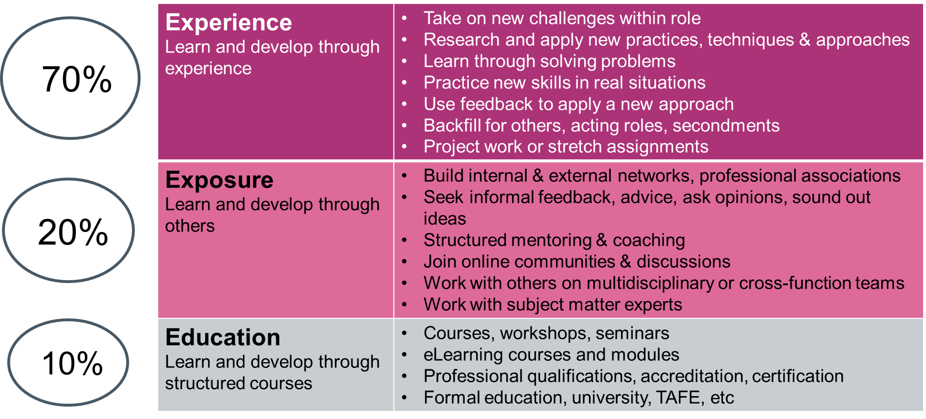

Note: Approval will need to be sought before confirming training requests.

|  |  |  |
| --- | --- | --- |
| **Learning and Development Need** | **L&D Delivery Method** | **Completion Date** |
|  |  |  |
|  |  |  |
|  |  |  |
|  |  |  |
|  |  |  |
|  |  |  |
|  |  |  |
|  |  |  |

# Optional professional practice conversation

If you have requested an optional meeting with your Manager to discuss your professional development you may like to respond to the following questions:

|  |
| --- |
| 1. **What has gone well for you this year? What do you consider your key achievements? (Optional)** |
| *You may wish to keep a record and share any feedback received from your colleagues, patients and students over the past 12 months.* |
| 1. **Are there any aspects of professional development that you require further advice or assistance with? (Optional)** |
| *Are there any new skills that you hope to attain or professional activities that you would like to be involved in?* |
| **3. Where do you see your career going and what help will you need to get there? (Optional)** |
| *Have you experienced any challenges achieving your CPD in the last year? Are there other positions you would like to relieve in the future? Is there additional study you would like to do but need some information? Are there some skills you would like to learn? Would you like the opportunity to upskill in a different area? Are you planning for retirement?* |

# **Comments**

|  |  |  |
| --- | --- | --- |
| **Comment by manager/supervisor: (OPTIONAL)** | | |
|  | | |
| **Employee:** | **HE # /Signature:** | **Date:** |
| **Name:** |  |  |
| **Manager:** | **HE # /Signature:** | **Date:** |
| **Name:** |  |  |

**This document can be made available in alternative formats   
on request for a person with a disability.**

© North Metropolitan Health Service 2024

Copyright to this material is vested in the State of Western Australia unless otherwise indicated. Apart from any fair dealing for the purposes of private study, research, criticism or review, as permitted under the provisions of the *Copyright Act 1968*, no part may be reproduced or re-used for any purposes whatsoever without written permission of the State of Western Australia.